Quantum Computing 2026-2126: A Century Forecast of Fault Tolerance, Cryptographic Transition, Industrial Disruption, and Civilizational Effects
Denis Borta
Student
August 2026
Abstract—This paper develops a 100-year scenario forecast for quantum computing from 2026 through 2126, organized into five eras and evaluated across hardware, cryptographic security, industrial economics, and civilizational effects. The near-term anchor is the 2026 experimental record: below-threshold surface-code operation in superconducting processors, below-threshold and universal fault-tolerance building blocks in neutral-atom arrays, a 98-qubit trapped-ion charge-coupled-device processor, and manufacturable integrated photonic components. The central thesis is that raw physical-qubit count is an inadequate measure of progress. The meaningful transition is from noisy intermediate-scale quantum computation to algorithm-grade logical qubits with sufficiently low logical error rates, high non-Clifford throughput, and scalable classical decoding. The paper distinguishes measured facts, vendor roadmaps, and author scenario estimates. It forecasts a heterogeneous quantum-classical architecture rather than a single winning modality; a security transition in which post-quantum cryptography (PQC) dominates general deployment while quantum key distribution (QKD) remains specialized; and a later quantum internet based on distributed entanglement rather than merely key exchange. The largest long-run economic effects are expected in strongly correlated chemistry, catalyst and materials design, selected stochastic finance and differential-equation workloads, and quantum-native machine learning. The deepest societal effect is not the elimination of scarcity, but a shift in scarcity from unknown chemistry toward energy, feedstock, fabrication capacity, and governance.
Index Terms—fault-tolerant quantum computing, quantum error correction, surface code, qLDPC, post-quantum cryptography, ML-KEM, ML-DSA, quantum key distribution, quantum internet, quantum chemistry, FeMoco, quantum finance, quantum machine learning.
I. INTRODUCTION
Quantum computing is often discussed as though a single threshold will separate a pre-quantum economy from a post-quantum one. That framing is physically and economically misleading. At least four thresholds matter: (1) error-corrected operation, where increasing code distance reduces logical error; (2) fault-tolerant operation, where universal logical computation can be sustained to arbitrary depth given sufficient resources; (3) economically useful fault-tolerant quantum computing (FTQC), where a quantum system beats the best classical alternative on a valuable problem; and (4) a cryptographically relevant quantum computer (CRQC), where fault-tolerant execution is sufficient to attack deployed RSA or elliptic-curve public-key cryptography at operationally meaningful cost. Preskill’s NISQ framing correctly emphasized the limitations of noisy processors, while the surface-code literature formalized the path by which physical redundancy can suppress logical error. [1], [2]
The empirical starting point in 2026 is stronger than it was even two years earlier, but still far from deep algorithmic FTQC. Google Quantum AI reported a distance-7 surface-code memory using 101 physical qubits with 0.143% logical error per error-correction cycle and below-threshold scaling as code distance increased. The same work reported rare correlated error bursts as an emerging logical-error floor. Neutral-atom experiments have implemented repeated below-threshold error correction and key elements of universal fault tolerance with reconfigurable arrays of up to 448 atoms. Quantinuum’s Helios platform reports 98 trapped-ion qubits with average two-qubit infidelity of 7.9 x 10^-4 and all-to-all logical programmability through a QCCD architecture. In photonics, a 300-mm-foundry-compatible platform has demonstrated high-fidelity state preparation, fusion, detection, and chip-to-chip transmission, while explicitly identifying optical loss and non-determinism as remaining barriers. [3]-[6]
These results justify a shift in forecasting methodology. Physical-qubit count alone is no longer a sufficient independent variable. A credible forecast must track logical error rate, code distance, error-correction overhead, non-Clifford state-factory throughput, decoder latency, modular interconnect fidelity, and the economic cost per reliable logical operation. This paper therefore treats “logical qubit” as an algorithmic resource, not as a marketing label: an encoded qubit that survives only a small number of logical operations is not equivalent to one capable of participating in a trillion-operation computation. [3], [7]
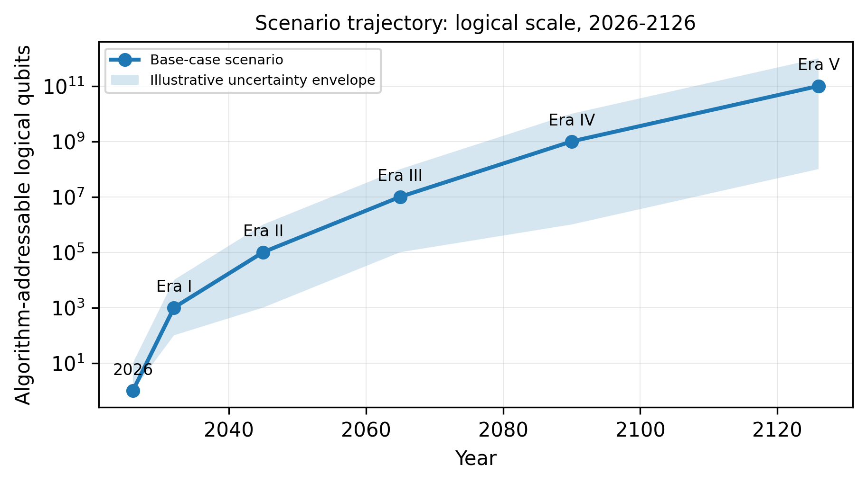
Fig. 1. Base-case scenario trajectory for algorithm-addressable logical qubits. The central line and uncertainty envelope are author forecasts, not measured data or consensus projections.
II. FORECAST METHOD AND PHYSICS CONSTRAINTS
A. Evidence Hierarchy and Uncertainty
The forecast uses three evidence classes. Class 1 consists of peer-reviewed experimental measurements and formal theory. Class 2 consists of government standards, migration guidance, and national infrastructure programs. Class 3 consists of vendor roadmaps, which are used only as indicators of engineering intent and are never treated as demonstrated capability. All numerical projections after 2026 are scenario estimates by the author. Confidence intentionally declines with time: Era I is medium-high confidence in direction, Era II medium, Era III low-medium, Era IV low, and Era V very low. Exact dates should therefore be read as scenario boundaries rather than predictions with calendar precision.
B. Error-Correction Scaling
For the surface code under simplified stochastic noise, the logical error probability per cycle is often approximated by a threshold form in which increasing code distance d exponentially suppresses error when the physical error probability p is below a threshold p_th. The 2025 Willow result states the scaling schematically as [3]
p_L ≈ A (p / p_th)^((d + 1)/2). (1)
For a rotated surface-code memory, the physical footprint scales approximately as 2d^2 - 1 physical qubits per logical patch before counting routing, ancillas, lattice-surgery workspace, and magic-state factories. Thus a code distance near 27 already implies roughly 1,457 physical qubits for one memory patch; the Willow authors estimated that such a distance would be required to reach about 10^-6 logical error per cycle under their measured noise extrapolation. Deep algorithms may need substantially lower aggregate failure probability. [3]
This overhead is why high-rate quantum low-density parity-check (qLDPC) codes matter economically. Bravyi et al. showed a bivariate-bicycle-family memory in which 12 logical qubits could, under a 0.1% circuit-noise model, be stored for nearly one million syndrome cycles using 288 physical qubits, compared with nearly 3,000 physical qubits in a surface-code comparison. The result is theoretical and connectivity-intensive, but it demonstrates that “physical-to-logical overhead” is not a fixed constant of nature. [7]
Error mitigation cannot simply replace error correction at large scale. General information-theoretic analyses show exponential or superpolynomial sampling overheads for broad classes of error-mitigation strategies as circuit depth and noise increase. The long-run transition therefore requires genuine entropy removal through QEC, not only statistical reconstruction of a noiseless answer. [8], [9]
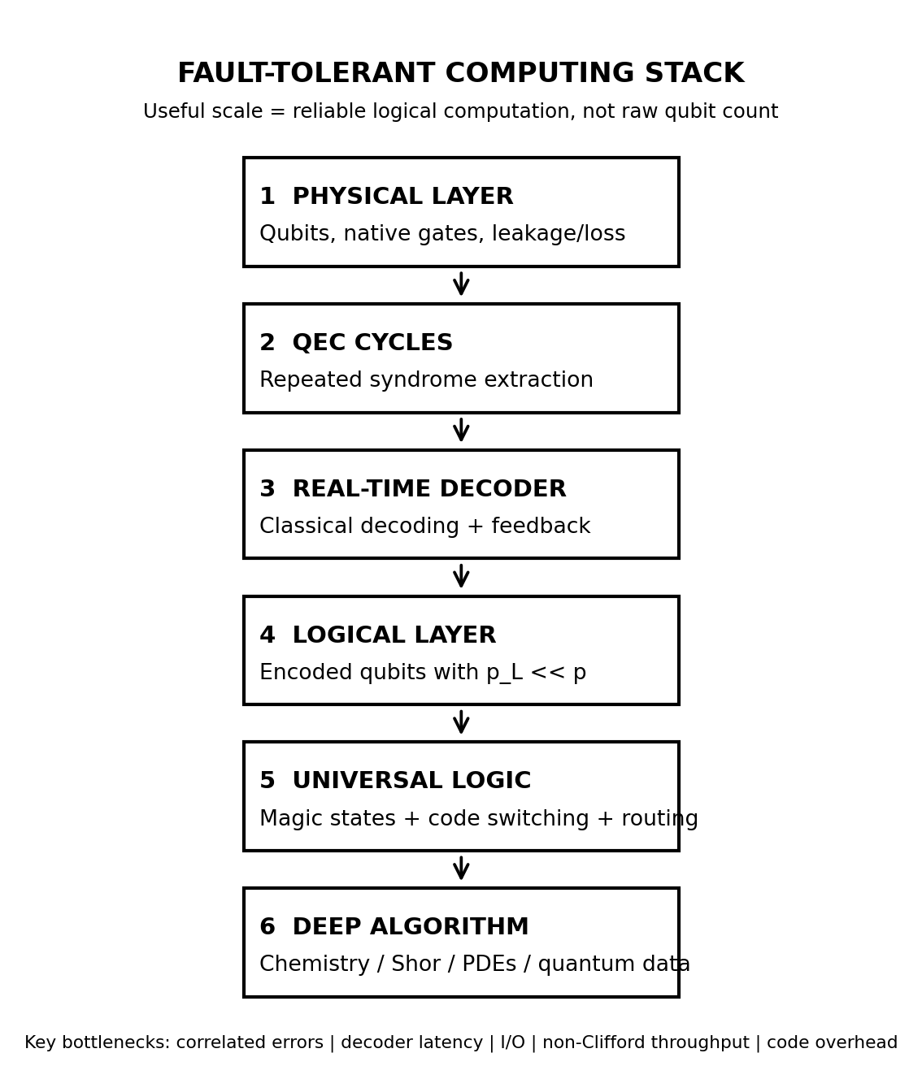
Fig. 2. Functional stack of a fault-tolerant quantum computer. Universal, deep computation requires the entire chain to scale; a large physical-qubit array alone is insufficient.
C. Forecast Envelope
TABLE I
SCENARIO FORECAST ENVELOPE
Era | Years | Logical  qubits | Phys.:Log.  overhead | Regime | Confidence
I | 2026-2032 | 10-10^3 | 10^2-10^4:1 | NISQ -> early FTQC | Med.-High
II | 2033-2045 | 10^3-10^5 | 30-10^3:1 | Commercial FTQC | Medium
III | 2046-2065 | 10^5-10^7 | 10-300:1 | Quantum-industrial infra. | Low-Med.
IV | 2066-2090 | 10^7-10^9 | 3-100:1 | Routine quantum design | Low
V | 2091-2126 | 10^8-10^11* | 2-30:1 | Distributed fabric | Very Low
*Era V refers to logical qubits addressable by a large job across a distributed fabric, not necessarily a single coherent monolithic chip. Overhead ratios are effective end-to-end scenario estimates and are workload-, code-, and modality-dependent.
III. ERA I: 2026-2032 - NISQ GIVES WAY TO EARLY FAULT TOLERANCE
A. Hardware Milestones
Era I is the period in which the central engineering question changes from “can a logical qubit beat a physical qubit?” to “can fault tolerance be sustained cheaply and continuously?” Superconducting circuits remain strong candidates for the first high-throughput surface-code machines because gate cycles are fast and planar fabrication is mature. Their liabilities are equally concrete: millikelvin operation, microwave-control density, leakage, frequency collisions, calibration drift, heat load, and correlated error mechanisms. Cosmic-ray and gamma-ray events have been shown to create correlated relaxation events across superconducting chips, violating the convenient independent-error assumptions used in many threshold models. [3], [10], [11]
Neutral atoms become the most serious architectural challenger in this era. Reconfigurable optical tweezers offer large arrays, atom rearrangement, native long-range interactions through Rydberg excitation, and direct detection of atom loss. The 448-atom fault-tolerance experiment is important not because 448 is a large number by classical standards, but because it demonstrates repeated QEC, logical entanglement, lattice surgery, and a path to universal gates in one architecture. The remaining problems are atom loss, Rydberg decay, optical phase stability, readout/reload cadence, and scaling many parallel high-fidelity optical controls. [4]
Trapped ions retain a fidelity and connectivity advantage. Helios demonstrates that a QCCD can physically shuttle ions between storage and logic regions while maintaining very high component fidelity. The strategic question is whether optical-system complexity, motional-mode management, ion transport, and slower entangling-gate clocks can be scaled without surrendering the fidelity advantage. A slow-clock architecture can require far more elapsed time than a fast superconducting machine for an equal logical-gate count; “one million qubits” is therefore not a meaningful cryptographic metric without logical throughput. [5]
Photonics offers a different trade: photons are naturally suited to networking and can be processed in semiconductor-compatible photonic circuits, but photon loss is destructive. The 2025 manufacturable photonics demonstration reported 99.22% two-qubit fusion fidelity and 99.72% chip-to-chip qubit interconnect fidelity conditional on photon detection and explicitly not accounting for loss. Practical fusion-based FTQC therefore depends on a total optical-loss budget, near-unit detection, fast multiplexing, deterministic-enough resource-state generation, and extremely high manufacturing yield across millions of components. [6]
Base-case milestone: by 2032 the most advanced systems reach roughly 10^2-10^3 algorithm-addressable logical qubits, with millions of physical qubits plausible at the largest installations. The first meaningful metrics become sustained logical operations, logical error per layer, and magic-state production rate. Error mitigation remains useful at the margins, but no longer defines the scaling path. IBM’s public roadmap, for example, targets error-corrected systems with hundreds of logical qubits and 10^8-gate execution by the end of the decade; this is useful as an engineering target, not as independent evidence that the target will be met. [12]
B. Cryptographic and Security Shifts
The cryptographic transition is already underway before the arrival of a CRQC. NIST finalized FIPS 203 (ML-KEM), FIPS 204 (ML-DSA), and FIPS 205 (SLH-DSA) in August 2024. ML-KEM provides module-lattice-based key encapsulation, ML-DSA provides module-lattice digital signatures, and SLH-DSA provides a hash-based signature alternative. NIST’s current migration material states that organizations should begin migrating now and that quantum-vulnerable algorithms are intended to be deprecated or removed from NIST standards by roughly 2035, with high-risk systems moving earlier. [13]-[17]
The operational sequence in Era I is therefore: inventory cryptographic dependencies; introduce crypto-agility; deploy hybrid classical-plus-PQC handshakes where appropriate; replace vulnerable key establishment and signatures in new systems; then address legacy PKI, firmware signing, HSMs, embedded controllers, satellites, and long-lived industrial equipment. The migration problem is organizational and architectural as much as mathematical. The relevant danger inequality is the harvest-now-decrypt-later condition: if the confidentiality lifetime of data plus migration time exceeds the time until a capable CRQC, recording ciphertext today can create a future intelligence asset even if the attacker cannot decrypt it now. [16], [18]
secret lifetime + migration time > time to CRQC => HNDL exposure (2)
A 2025 resource estimate by Gidney illustrates why security planning cannot rely on today’s small demonstrations. Under assumptions of 0.1% physical gate error, a 1 microsecond surface-code cycle, a 10 microsecond control reaction time, and a nearest-neighbor planar architecture, the estimate places RSA-2048 factoring below one million noisy physical qubits and below one week of runtime. This is a theoretical preprint resource estimate, not an existing machine, but it shows how algorithmic and QEC improvements can change CRQC requirements by orders of magnitude. [18]
QKD expands in specialized settings but does not replace PQC. NSA’s public guidance continues to regard QKD as less cost-effective and operationally more fragile than quantum-resistant algorithms for National Security Systems, citing dedicated hardware, authentication, implementation vulnerabilities, trusted relay issues, and denial-of-service concerns. Europe nevertheless continues the EuroQCI build-out with terrestrial fiber and a space segment; the Eagle-1 prototype is currently planned for late 2027. This is best interpreted as specialized high-assurance infrastructure, not evidence that all Internet security will become QKD. [19], [20]
C. Macroeconomic and Industrial Impact
Era I produces more pilots than revolutions. The strongest early industrial use cases are small active-space chemistry, correlated-material subproblems, calibration/control optimization, and workflow integration with classical HPC. The economically realistic architecture is classical screening plus a QPU subroutine, not an isolated quantum computer replacing an entire simulation stack. For strongly correlated chemistry, modern resource estimates still involve billions of non-Clifford operations and thousands of logical qubits, placing landmark systems such as FeMoco mainly in Era II rather than the late-NISQ period. [21], [22]
Finance remains similarly conditional. Quantum amplitude estimation can in principle reduce Monte Carlo error scaling from O(1/sqrt(N)) sampling to an O(1/N)-type dependence in idealized settings, motivating derivative pricing, credit valuation adjustment, Value-at-Risk tails, and rare-event calculations. The practical advantage depends on state preparation, fault-tolerant depth, data loading, and the competitiveness of classical variance-reduction methods. The existence of a quadratic asymptotic advantage is not the same as a wall-clock advantage. [23]
Quantum machine learning on ordinary classical data is a weak investment thesis in this era. Quantum kernels can exhibit exponential concentration, forcing exponentially many measurement shots to resolve useful distinctions between kernel entries under broad conditions. QML is more defensible when the data are themselves quantum-mechanical or when the quantum subroutine accesses structure that is difficult to reproduce classically. [24]
D. Civilizational and Societal Shift
The first civilization-scale effect of quantum computing is therefore not a miracle material. It is a forced replacement cycle in the global trust infrastructure. Governments and large enterprises must inventory cryptography embedded across decades of software, firmware, industrial hardware, identity systems, and archives. At the same time, dilution refrigerators, lasers, cryogenic electronics, single-photon detectors, high-purity materials, photonic foundries, and QEC software become strategic supply chains. Quantum geopolitics in Era I resembles semiconductor geopolitics more than science fiction.
Transition bottleneck to Era II: the field must demonstrate repeatable logical computation at useful depth, with correlated-error suppression, decoder throughput, cryogenic or optical control scaling, modular interconnects, and economically tolerable non-Clifford factories. A device that can make many logical qubits but cannot feed them reliable T/Toffoli resources will not deliver deep algorithmic advantage. [3], [7], [10]
IV. ERA II: 2033-2045 - COMMERCIALLY IMPORTANT FTQC
A. Hardware Milestones
Era II is the first period in which failure to demonstrate economic advantage would plausibly trigger a major capital reset. The base case is 10^3-10^4 high-quality logical qubits near 2040 and 10^4-10^5 by 2045, with sustained logical depth becoming more important than qubit count. Surface codes remain important because of local connectivity and relatively high threshold, but the economic pressure to reduce overhead drives qLDPC, bosonic, biased-noise, erasure-aware, and code-switching architectures. High-rate codes are especially valuable because magic-state factories and routing can otherwise dominate machine footprint. [7]
The likely “winning modality” is therefore not singular. Superconducting systems may dominate high-clock-rate compute; neutral atoms may excel at large reconfigurable arrays and memory-rich layouts; trapped ions may retain a premium role in high-fidelity workloads; and photonics may become both a compute modality and the natural interconnect fabric. The mature analogy is more likely CPU/GPU/network heterogeneity than one transistor technology erasing every alternative.
A crucial theoretical constraint persists regardless of hardware. The Eastin-Knill theorem rules out a universal set of transversal logical gates for a conventional exact quantum error-correcting code, so scalable universality still requires mechanisms such as magic-state distillation or cultivation, code switching, gauge fixing, teleportation, or topological operations. Manufacturing improvement cannot repeal this structural requirement. [25]
B. Cryptographic and Security Shifts
By approximately 2035, competently managed systems should no longer depend on RSA, finite-field Diffie-Hellman, ECDH, or ECDSA for new protection of long-lived sensitive information. NIST’s published transition material identifies 2030 and 2035 as key deprecation/disallowance horizons, while NSA’s CNSA 2.0 program requires a staged migration for National Security Systems. The residual risk is concentrated in abandoned devices, old signatures, offline archives, dormant digital assets, satellites, industrial systems, and organizations that failed to migrate. [16], [17], [26]
The central CRQC forecast in this paper is 2038-2045, with a deliberately wide uncertainty band: an aggressive case in the mid-2030s, a base case centered around the early 2040s, and a slow case after 2050. This is an author scenario, not a standards-agency prediction. The key metric is not merely physical qubits but logical modular-exponentiation throughput under a specific error-corrected clock. A slow trapped-ion CRQC and a fast superconducting CRQC with equal qubit counts need not create equal operational risk. [18]
When a CRQC arrives, the likely security event is less cinematic than “the Internet breaks.” If migration succeeds, live high-value traffic is mostly PQC-protected. The shock is retrospective: stored ciphertext becomes readable, neglected assets become vulnerable, and historical signatures or ownership records may require migration or trusted timestamping. HNDL becomes harvested-then-decrypted. QKD remains concentrated in high-assurance links, while the first true repeater-based metro quantum networks begin to distribute entanglement rather than only keys. [19], [27]
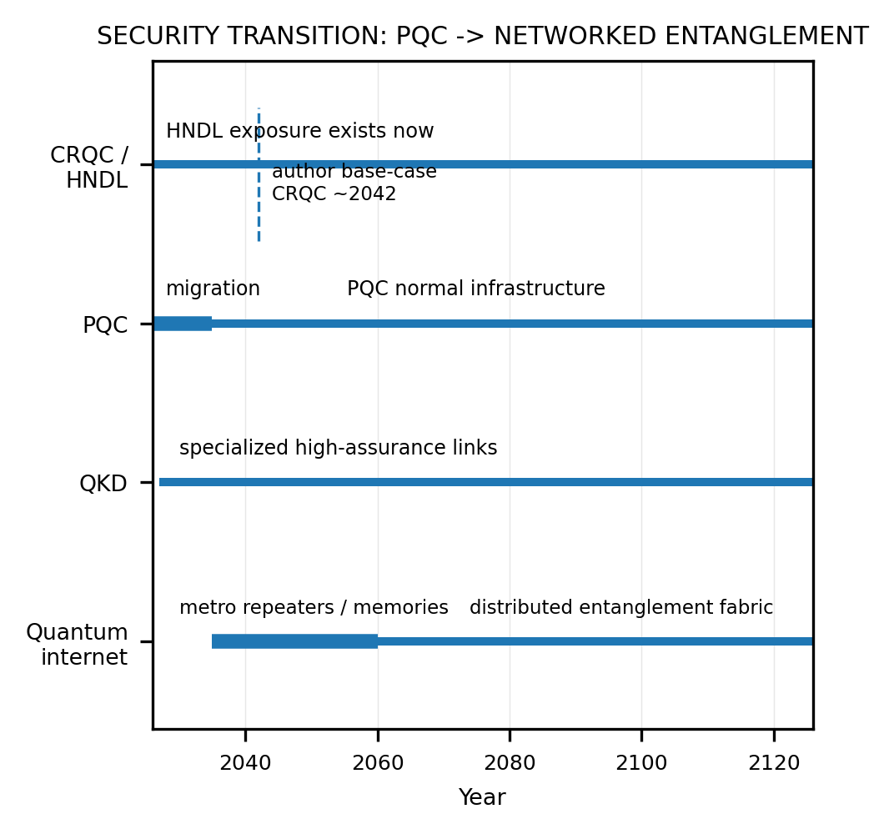
Fig. 3. Scenario security transition. PQC is expected to dominate broad deployment; QKD remains specialized; a true quantum internet arrives later when networks can distribute and preserve entanglement through repeaters and memories.
C. Macroeconomic and Industrial Impact
The most plausible first unambiguous FTQC value is quantum simulation of strongly correlated electronic structure. FeMoco, the iron-molybdenum cofactor in nitrogenase, is a canonical benchmark because its correlated transition-metal chemistry is difficult for classical electronic-structure methods and is directly relevant to understanding biological nitrogen fixation. A 2024 symmetry-compressed double-factorization study reported about 2.4 x 10^9 Toffoli gates and roughly 3,700 logical qubits for one active-space FeMoco model; prior tensor-hypercontraction work estimated about 2,142 logical qubits and 5.3 x 10^9 Toffolis, with a physical-layout estimate of about four million physical qubits under aggressive surface-code assumptions. [21], [22]
The economic chain is not “solve FeMoco, end Haber-Bosch.” A plausible chain is quantum ground-state and reaction-path calculation -> mechanistic understanding -> catalyst hypothesis -> classical molecular dynamics and reactor modeling -> robotic synthesis -> industrial process validation. If that chain yields lower-temperature or lower-pressure nitrogen fixation, electrochemical ammonia, or more selective catalysts, the value is in energy and capital efficiency across a gigantic chemical system. Catalyst stability, poisoning, kinetics, feedstock purity, and reactor engineering remain classical constraints.
Battery and polymer industries become second-wave beneficiaries. High-value QPU tasks include electrolyte decomposition, transition-metal redox, solid-electrolyte interphase chemistry, defects, radical pathways, catalyst-controlled tacticity, ion-conducting polymers, conductive polymers, membrane selectivity, and degradation reactions. The QPU solves the electronically hard fragment; classical molecular dynamics and continuum models still determine mesoscale transport and device behavior.
Finance reaches selective production use only where the end-to-end state-preparation and readout cost does not erase the algorithmic speedup. The strongest candidates remain high-dimensional Monte Carlo and rare-event problems: CVA, counterparty exposure, insurance tails, option portfolios, and selected stochastic-process calculations. Quantum algorithms for nonlinear differential equations are an active research area, but even recent reviews emphasize limitations in nonlinearity, integration time, state preparation, and extraction of classical observables. [23], [28]
D. Civilizational and Societal Shift
The R&D loop begins to compress from experiment-first search toward simulation-guided automation: AI proposes hypotheses, classical HPC narrows the space, fault-tolerant QPUs solve the hard quantum subproblem, robotic laboratories test a much smaller candidate set, and measured results retrain the models. The strategic national resource becomes the rate at which a society can close this simulation-fabrication-measurement loop, combining compute, energy, fabrication, and scientific institutions.
Transition bottleneck to Era III: commercially useful quantum advantage must become repeatable across more than a handful of bespoke demonstrations. The decisive constraints are logical gate rate, cost per algorithmic result, modular fault-tolerant interconnects, compiler automation, and code overhead. If those costs do not fall, classical AI and HPC will absorb much of the market that quantum vendors currently expect to capture.
V. ERA III: 2046-2065 - QUANTUM-INDUSTRIAL INFRASTRUCTURE
A. Hardware Milestones
The Era III base case is 10^5-10^7 algorithm-addressable logical qubits, increasingly distributed across modular processors. The critical architectural breakthrough is not a gigantic monolithic coherent wafer; it is fault-tolerant modularity. Photonic entanglement links connect specialized compute and memory modules so that manufacturing yield, refrigerator size, optical field of view, ion-trap dimensions, and packaging cease to impose a single-chip ceiling. Quantum programs are scheduled across CPU, GPU, AI accelerators, QPUs, classical decoders, and photonic switches.
A true distributed machine requires high-rate heralded entanglement, quantum memories with adequate lifetime and bandwidth, routing, purification or network-level QEC, and tight synchronization. Classical repeaters cannot simply amplify an unknown qubit because arbitrary quantum states cannot be cloned. DOE quantum-network roadmaps therefore emphasize repeaters, switching/routing of entanglement, error correction, and multihop networks as distinct from ordinary optical communications. [27], [29]
B. Cryptographic and Security Shifts
PQC is now boring infrastructure, which is the desired outcome. The security frontier moves to implementation errors, side channels, protocol composition, supply-chain compromise, hardware trojans, cryptographic agility, and AI-assisted vulnerability discovery. QKD is used where high assurance justifies physical infrastructure. Regional quantum networks increasingly interconnect processors, atomic clocks, sensors, and laboratories. The meaningful network metric is entanglement generation rate multiplied by fidelity and usable distance, not raw fiber length. [19], [27]
C. Macroeconomic and Industrial Impact
Quantum simulation becomes a routine input to inverse design for catalysts, corrosion-resistant alloys, semiconductor defects, photovoltaics, thermoelectrics, battery materials, carbon-capture sorbents, membranes, magnetic materials, and superconductors. The machine does not normally represent a macroscopic turbine blade as one exact wavefunction. It solves the quantum-mechanical component that classical methods approximate poorly and passes energies, forces, transition amplitudes, or effective Hamiltonians into classical multiscale models.
Polymer design becomes an especially large market because performance is inherently multiscale. Firms increasingly specify a vector of desired properties - dielectric response, glass-transition temperature, strength, permeability, chemical resistance, recyclability, ion conductivity, and synthesis cost - then search backward toward molecular motifs and process conditions. Quantum subroutines are valuable only where electronic correlation, photochemistry, bond breaking, or catalytic pathways dominate the uncertainty.
Energy systems are affected in two distinct layers. At the matter layer, better catalysts, power electronics, storage materials, photovoltaics, and possibly superconductors alter generation, transmission, and storage technology. At the systems layer, quantum and quantum-inspired optimization address stochastic unit commitment, storage scheduling, expansion planning, and large scenario trees. Fast protective relays remain classical because local deterministic reliability and millisecond response matter more than exotic global optimization.
For nonlinear differential equations, the plausible value is narrow but significant: structured high-dimensional problems in fluid dynamics, plasma physics, reaction networks, finance, and inverse problems. Recent research continues to extend quantum algorithms for nonlinear PDEs, while also emphasizing that nonlinearity, long integration time, measurement overhead, and state preparation can destroy nominal speedups. “Quantum solves CFD” is therefore not a universal claim; it is a conditional accelerator story. [28], [30]
D. Civilizational and Societal Shift
This is the beginning of engineered abundance in a specific sense. If computation makes it possible to design a substitute for a material whose performance previously depended on a scarce element, the scarcity has not vanished; it has moved. Geological scarcity can be replaced by requirements for energy, common feedstocks, purification, fabrication equipment, licensing, and manufacturing capacity. Countries whose leverage comes from one mineral deposit can lose bargaining power, while countries controlling photonics, advanced fabrication, power generation, and automated chemistry gain it.
The relevant geopolitical production function increasingly resembles energy x compute x automation x manufacturing. This does not eliminate commodity geopolitics: quantum processors themselves depend on high-purity materials, specialty gases, isotopes, photonics, cryogenics, and semiconductor tools. It changes which bottlenecks matter and increases the strategic value of the capacity to invent substitutes quickly.
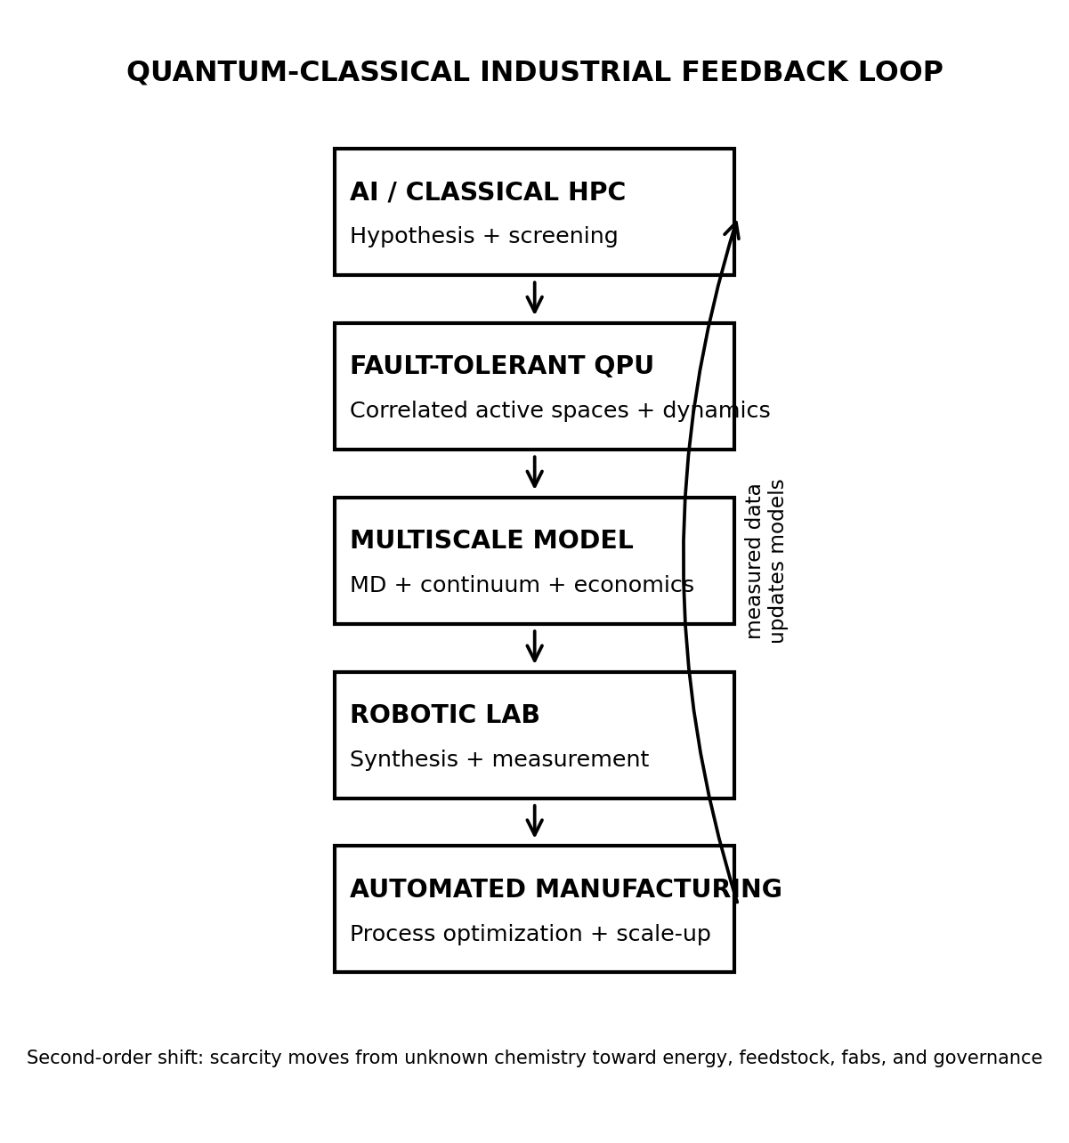
Fig. 4. Mature quantum-classical industrial loop. The QPU is a specialized accelerator embedded in AI/HPC, multiscale simulation, robotic experimentation, and manufacturing feedback.
Transition bottleneck to Era IV: high-fidelity quantum networking and modular QEC must become routine enough that a single job can span many fault-tolerant modules without network errors dominating. At the application layer, chemistry and materials workflows must demonstrate not just accurate energies but validated industrial outcomes.
VI. ERA IV: 2066-2090 - CHEMISTRY AND MATERIALS ENTER DESIGN MODE
A. Hardware Milestones
The Era IV base case is 10^7-10^9 logical qubits across frontier distributed systems, although raw count becomes increasingly uninformative. More useful measures include logical operations per second, fault-tolerant spacetime volume, magic-state throughput, entanglement bandwidth, and quantum-memory volume. Effective physical-to-logical overhead may fall to single digits or tens in favorable codes and hardware, but this outcome depends on physical error rates, connectivity, bias, and decoder performance and is not guaranteed by Moore’s-law-style scaling.
The likely architecture is a stack: stationary or matter qubits for storage and local computation, photonic channels for movement and entanglement, and highly integrated classical control. Superconducting, neutral-atom, ion, spin, bosonic, photonic, or genuinely topological components may each occupy niches. This paper does not assume that topological/Majorana hardware wins; its theoretical appeal must still be converted into experimentally reproducible, scalable, fault-tolerant devices.
B. Cryptography and the Mature Quantum Network
Shor’s algorithm is no longer the dominant security story because functioning institutions migrated decades earlier. Quantum communication becomes valuable for capabilities that PQC alone does not provide: distributed entanglement, networked quantum sensing, remote quantum computation, clock synchronization, and delegated or blind quantum protocols. A quantum internet is therefore complementary to the classical Internet rather than a replacement; classical bits remain vastly cheaper to copy, cache, amplify, and broadcast. [27], [29]
C. Macroeconomic and Industrial Impact
“Perfect chemical simulation” should not be interpreted literally. Real chemistry involves electronic structure, nuclei, relativistic effects, solvents, thermal distributions, open-system dynamics, defects, and nonequilibrium processes. The more defensible forecast is systematic improvability: difficult electronic-structure and quantum-dynamics calculations become controllably accurate enough that uncertainty migrates to mesoscale physics, kinetics, and manufacturing. That is sufficient to change chemical engineering.
Catalyst design becomes increasingly inverse: specify selectivity, turnover, stability, temperature, pressure, and feedstock constraints, then search the physically feasible reaction landscape. Candidate targets include lower-energy nitrogen fixation, carbon dioxide conversion, methane functionalization, selective oxidation, hydrogen evolution, synthetic fuels, and polymer depolymerization. Quantum computing cannot guarantee that a desired catalyst or ambient-condition superconductor exists; it can only expose what the laws of physics permit more efficiently.
Biological chemistry becomes more programmable when accurate active-site quantum mechanics is combined with mature protein design. The hierarchy remains multiscale: quantum active region -> molecular dynamics -> cellular model -> organism. Whole cells do not become single wavefunctions simply because processors are larger. The value is the ability to reduce uncertainty in the electronically hard steps of catalysis, photochemistry, charge transfer, and metalloprotein function.
D. Civilizational and Societal Shift
Materials scarcity is partially replaced by computational scarcity. Better separation membranes, recycling catalysts, substitute magnets, alternative battery chemistries, and lower-temperature industrial processes can reduce dependence on particular ore bodies. Yet the new bottlenecks are large and physical: electricity, feedstock, fabs, robotic factories, shipping, land, water, and political permission. Quantum-enabled design therefore supports a more circular materials economy without violating thermodynamics.
Energy geopolitics changes if improved storage, catalysts, photovoltaics, superconductors, fusion materials, or synthetic fuels mature together. Hydrocarbon rents can decline while reliable low-cost electricity becomes even more strategic because it powers computation, automated chemistry, desalination, recycling, and manufacturing. The new center of gravity is not “who owns the largest oil field?” but “who can convert energy and knowledge into useful matter fastest?”
Transition bottleneck to Era V: the quantum network must mature from specialized laboratory infrastructure into an operating fabric with predictable service levels, while QEC and compiler stacks hide most physical details from users. Governance becomes as important as physics because the societal value of near-automated materials discovery depends on access, safety, industrial capacity, and distribution.
VII. ERA V: 2091-2126 - QUANTUM COMPUTATION BECOMES INFRASTRUCTURE
A. Hardware Milestones and Hard Limits
The century-end base case is 10^8-10^11 logical qubits addressable by very large jobs across distributed quantum fabrics. The phrase “one quantum computer” becomes less useful: a computation may dynamically allocate logical blocks across processors, memories, photonic routers, and remote datacenters. Quantum resources are scheduled much as cloud accelerators are scheduled today, with error budgets and entanglement links treated as compiler-managed resources.
Physics continues to impose hard constraints. No-cloning remains true; measurement remains invasive; decoherence still exists; error correction consumes entropy and hardware; causality forbids superluminal communication; and the Holevo bound constrains extraction of classical information from quantum states. Quantum computers do not provide exponentially many classical answers merely because a state occupies an exponentially large Hilbert space. There is also no known general polynomial-time quantum algorithm for NP-complete optimization, and quantum computation does not solve undecidable problems. Mature quantum infrastructure is powerful because it accelerates specific structures, not because it abolishes complexity theory. [25], [29]
B. Cryptography
Cryptography becomes continuously agile. No public-key primitive is treated as immortal. PQC coexists with quantum authentication, entanglement-assisted protocols, and information-theoretic primitives where their hardware cost is justified. The classical Internet remains the dominant carrier for ordinary information; quantum links augment it for tasks in which preserving or sharing quantum states is itself the resource.
C. Industrial Impact
The mature industrial stack combines AI scientists, classical supercomputers, fault-tolerant quantum accelerators, robotic laboratories, and automated factories. For materials, users specify property vectors and manufacturing constraints; the computational system searches physically realizable structures; robots synthesize candidates; sensors characterize them; and the data update the models. Materials science becomes substantially more inverse-design-driven than discovery-driven.
Pharmaceutical and biological applications improve at the electronic and molecular layers - binding chemistry, reaction mechanisms, enzyme design, photophysics, and selected dynamical processes - but they do not eliminate organism-level complexity, evolution, clinical variability, or the need for empirical trials. Climate applications similarly benefit through catalysts, atmospheric chemistry, carbon capture, grid planning, membranes, and materials, while remaining constrained by social systems and chaotic dynamics.
D. Civilizational Paradigm: Scarcity Migrates Up the Stack
Even if humanity can design a large fraction of chemically permissible molecules and materials more reliably, scarcity does not disappear. It changes form. In 2026 scarcity is a mixture of rare materials, limited knowledge, energy, and manufacturing. In the mature scenario, ignorance is smaller, but energy, atoms, feedstock, fabrication capacity, land, time, logistics, institutions, and governance remain. A perfect candidate material still needs kilograms or megatons of matter and a process capable of manufacturing it.
scarcity_2126 ≈ energy + feedstock + manufacturing + land + time + governance (3)
The deepest civilizational change is therefore epistemic: ignorance becomes a smaller component of material scarcity. Societies become better at asking “what matter is physically possible?” and rapidly converting the answer into engineered systems. This is a more defensible endpoint than post-scarcity science fiction because it respects thermodynamics, computation theory, and the cost of production.
VIII. CROSS-ERA BOTTLENECKS AND FALSIFICATION TESTS
A. Bottleneck Matrix
TABLE II
HARDWARE TRADE SPACE
Modality | Structural  advantage | Primary scaling bottleneck | Required transition
Superconducting | Fast gates; fab ecosystem | mK cooling, wiring, leakage, crosstalk, correlated radiation events | Cryo-control + modular packaging
Neutral atoms | Large arrays; rearrangement; connectivity | Atom loss, Rydberg decay, optical parallelism, readout cadence | Loss-aware QEC + parallel optics
Trapped ions | Very high fidelity; connectivity | Gate/transport speed, optics, motional modes | QCCD throughput + laser scaling
Photonics | Networking-native; foundry path | Loss, source nondeterminism, detectors, switching | Near-unit optical efficiency + multiplexing
All modalities | Logical abstraction | Decoder latency, magic states, code overhead, compiler complexity | End-to-end logical cost decline
The strongest falsification test for the optimistic forecast is economic, not rhetorical: does the cost per verified algorithmic result fall faster than classical alternatives improve? If quantum advantage requires a custom team, a giant cryogenic installation, and days of runtime to beat a classical cluster by a small factor, market adoption will remain narrow. Conversely, a modest number of decisive chemistry or security applications can justify very expensive machines if each result is worth billions of dollars.
B. What This Forecast Bets Against
• NISQ error mitigation alone becomes a scalable substitute for QEC. Fundamental results make broad, deep error mitigation increasingly sample-expensive. [8], [9]
• Quantum kernels replace GPUs for ordinary machine learning. Exponential concentration and data-loading/measurement costs make generic classical-data QML a weak base case. [24]
• QKD replaces software cryptography. PQC is cheaper and easier to deploy at Internet scale; QKD remains specialized unless its engineering limitations change dramatically. [19]
• One qubit modality wins every workload. The forecast instead expects heterogeneous specialization and photonic interconnection.
• Quantum computers solve optimization generally. No known complexity-theoretic result supports a universal efficient solver for NP-complete problems.
• Quantum simulation eliminates resource scarcity. It can reduce informational scarcity but cannot remove energy, atoms, fabrication, logistics, or thermodynamics.
IX. DEEP-TECH CAPITAL AND INDUSTRIAL STRATEGY
From a venture-capital perspective, the most defensible near-term investments are enabling layers whose value survives uncertainty about the winning qubit: cryogenic and optical control, test and measurement, photonic interconnects, error-correction software, compilers, resource estimation, calibration automation, high-purity materials, packaging, and security migration. Application companies are strongest when they own proprietary domain data, classical workflow integration, and a credible path to use increasingly capable QPUs rather than betting their entire value on a single near-term quantum speedup.
Capital discipline should focus on logical economics. Useful diligence metrics include physical error and leakage by operation; error correlations; logical error per cycle and per operation; decoder latency; code distance; logical clock rate; non-Clifford throughput; inter-module entanglement rate; calibration burden; availability; and cost per completed algorithmic workload. Vendor “qubit counts” without these metrics should be treated as incomplete information.
National industrial policy will increasingly treat PQC migration, quantum foundries, cryogenic electronics, photonics, laser supply chains, advanced packaging, and workforce development as strategic infrastructure. The eventual value is likely concentrated not in consumer quantum devices but in cloud-scale scientific and industrial systems whose outputs diffuse through chemistry, energy, finance, defense, and manufacturing.
X. CONCLUSION
The most plausible 100-year trajectory is not a clean exponential in qubit count. It is a sequence of architectural phase transitions: NISQ -> below-threshold QEC -> early FTQC -> economically useful FTQC -> modular quantum-HPC -> distributed quantum infrastructure. The gating variable is the cost of reliable logical spacetime volume, not physical-qubit count.
Security moves first because a future CRQC changes the value of ciphertext collected today. PQC therefore becomes standard infrastructure before large-scale quantum computing is economically ubiquitous. QKD grows in high-assurance niches, while a true quantum internet arrives later when repeaters, memories, routing, and network-level error correction make distributed entanglement useful. [13]-[20], [27]
The largest industrial upside is likely in domains where nature itself is quantum and classical representations become expensive: strongly correlated chemistry, materials, catalysts, and selected quantum-native data problems. Finance and nonlinear solvers may matter in narrower structured regimes, while generic QML and generic combinatorial optimization should be discounted unless new theory changes the current picture. [21]-[24], [28], [30]
The long-run societal result is not unlimited computation or post-scarcity economics. It is a reduction in the amount of scarcity caused by not knowing which materials, reactions, and quantum states are feasible. If the engineering succeeds, the defining shift of the century is from discovering useful matter largely by experiment toward designing physically possible matter with an increasingly tight computational and automated-manufacturing loop.
REFERENCES
[1] J. Preskill, “Quantum Computing in the NISQ era and beyond,” Quantum, vol. 2, p. 79, 2018. Link
[2] A. G. Fowler, M. Mariantoni, J. M. Martinis, and A. N. Cleland, “Surface codes: Towards practical large-scale quantum computation,” Phys. Rev. A, vol. 86, 032324, 2012. Link
[3] Google Quantum AI and Collaborators, “Quantum error correction below the surface code threshold,” Nature, vol. 638, pp. 920-926, 2025. Link
[4] D. Bluvstein et al., “A fault-tolerant neutral-atom architecture for universal quantum computation,” Nature, 2025. Link
[5] A. Ransford et al., “A 98-qubit trapped-ion quantum computer with all-to-all connectivity,” Nature, vol. 655, pp. 81-86, 2026. Link
[6] PsiQuantum Team, “A manufacturable platform for photonic quantum computing,” Nature, vol. 641, pp. 876-883, 2025. Link
[7] S. Bravyi, A. W. Cross, J. M. Gambetta, D. Maslov, P. Rall, and T. J. Yoder, “High-threshold and low-overhead fault-tolerant quantum memory,” Nature, vol. 627, pp. 778-782, 2024. Link
[8] Y. Quek, D. S. Franca, S. Khatri, J. J. Meyer, and J. Eisert, “Exponentially tighter bounds on limitations of quantum error mitigation,” Nat. Phys., vol. 20, pp. 1648-1658, 2024. Link
[9] R. Takagi, S. Endo, S. Minagawa, and M. Gu, “Fundamental limits of quantum error mitigation,” npj Quantum Inf., vol. 8, art. 114, 2022. Link
[10] C. D. Wilen et al., “Correlated charge noise and relaxation errors in superconducting qubits,” Nature, vol. 594, pp. 369-373, 2021. Link
[11] M. McEwen et al., “Resolving catastrophic error bursts from cosmic rays in large arrays of superconducting qubits,” Nat. Phys., vol. 18, pp. 107-111, 2022. Link
[12] IBM Quantum, “Quantum Development and Innovation Roadmap - 2024 Update,” 2024. [Online]. Link
[13] National Institute of Standards and Technology, FIPS 203, “Module-Lattice-Based Key-Encapsulation Mechanism Standard,” Aug. 2024. Link
[14] National Institute of Standards and Technology, FIPS 204, “Module-Lattice-Based Digital Signature Standard,” Aug. 2024. Link
[15] National Institute of Standards and Technology, FIPS 205, “Stateless Hash-Based Digital Signature Standard,” Aug. 2024. Link
[16] D. Moody, R. Perlner, A. Regenscheid, A. Robinson, and D. Cooper, “Transition to Post-Quantum Cryptography Standards,” NIST IR 8547 Initial Public Draft, Nov. 2024. Link
[17] National Institute of Standards and Technology, “Post-Quantum Cryptography,” current migration guidance, accessed Aug. 2026. [Online]. Link
[18] C. Gidney, “How to factor 2048 bit RSA integers with less than a million noisy qubits,” arXiv:2505.15917, 2025. Link
[19] National Security Agency, “Quantum Key Distribution (QKD) and Quantum Cryptography (QC),” cybersecurity guidance, accessed Aug. 2026. [Online]. Link
[20] European Commission, “European Quantum Communication Infrastructure - EuroQCI,” updated Jul. 2026. [Online]. Link
[21] M. Motta et al., “Reducing the Runtime of Fault-Tolerant Quantum Simulations in Chemistry through Symmetry-Compressed Double Factorization,” J. Chem. Theory Comput., vol. 20, no. 11, pp. 4639-4653, 2024. Link
[22] J. Lee et al., “Even More Efficient Quantum Computations of Chemistry Through Tensor Hypercontraction,” PRX Quantum, vol. 2, 030305, 2021. Link
[23] D. Herman et al., “Quantum computing for finance,” Nat. Rev. Phys., vol. 5, pp. 450-465, 2023. Link
[24] S. Thanasilp, S. Wang, M. Cerezo, and Z. Holmes, “Exponential concentration in quantum kernel methods,” Nat. Commun., vol. 15, art. 5200, 2024. Link
[25] B. Eastin and E. Knill, “Restrictions on transversal encoded quantum gate sets,” Phys. Rev. Lett., vol. 102, 110502, 2009. Link
[26] National Security Agency, “Commercial National Security Algorithm Suite 2.0 (CNSA 2.0) FAQ,” ver. 2.1, Dec. 2024. [Online]. Link
[27] U.S. Department of Energy, “U.S. Department of Energy Unveils Blueprint for the Quantum Internet,” Jul. 2020. [Online]. Link
[28] F. Tennie, S. Laizet, S. Lloyd, et al., “Quantum computing for nonlinear differential equations and turbulence,” Nat. Rev. Phys., vol. 7, pp. 220-230, 2025. Link
[29] U.S. Department of Energy, “DOE Explains...Quantum Networks,” accessed Aug. 2026. [Online]. Link
[30] P. C. S. Costa et al., “Further improving quantum algorithms for nonlinear differential equations via higher-order methods and rescaling,” npj Quantum Inf., vol. 11, art. 141, 2025. Link
AI USE DISCLOSURE
This paper was prepared with assistance from ANNIE, an experimental research harness for research synthesis, drafting, citation organization, and generation of original schematic diagrams.

